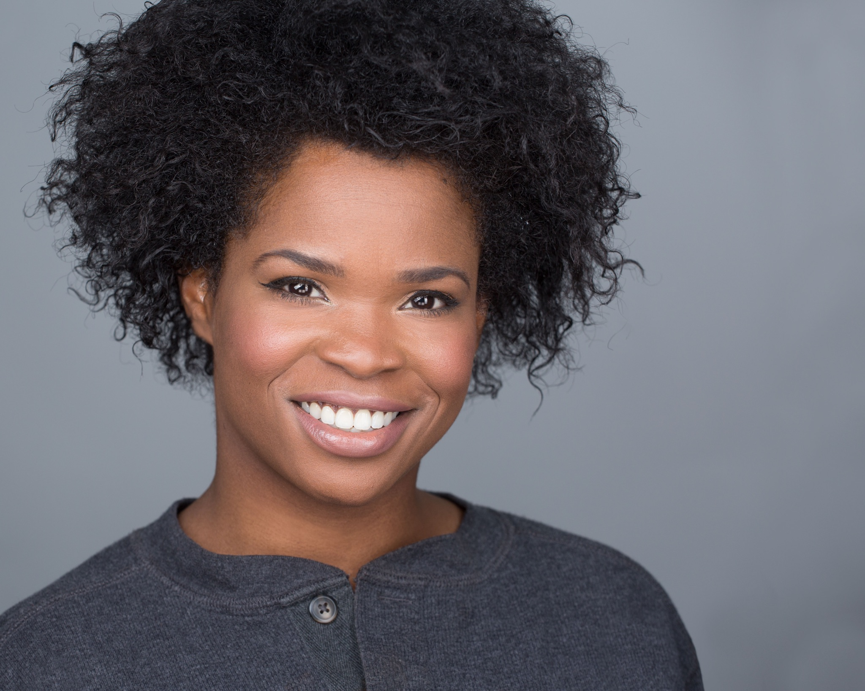 | Jaquesha J Abraham, Actress/Model  HEIGHT 5’ 5’’ WEIGHT 130LBS  BROWN HAIR/BROWN EYES  T : 310-595-8461  Jaquesha.Abraham@gmail.com
Stage:
Matrix Hair show (Phoenix Fashion Week 2015)
Joico Hair Show (Cincinnati Fashion Week 2008)
Regional Shakespeare Competition, (2006)
Theatre:
Actors Gym Zephyr Theatre, (Los Angeles, CA 2017)
Jeffersontown High School Theatre (2006)
Grant Middle School Theatre
Publications :
Coquette (1886 Films)
THWACPEP Project (2016)
Scottsdale Images B&W (2011)
Additional Training:
Carrie Zappa (2006-07)
William & Elaina Burns (2017)
Delta Sigma Theta Jabberwocky Debutant (2006)
Representation & Affiliations:
The Young Agency (2016-current)
Katalyst.TV (2006-08)

